**STEPPER MOTOR:** A stepper motor is a special dc motor which rotates in discrete angular steps in response to a programmed sequence of electrical input pulses. It is also known as step or stepping motor.

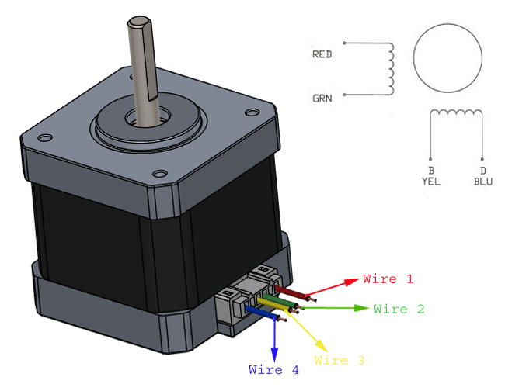

-There are 3 basic types of stepper motor based on rotor construction. They are

1. Variable reluctance type.
2. Permanent magnet.
3. Hybrid stepper motor.

-windings in stepper motor are of 2 types

1. Unipolar- Uses only half of the winding during excitation.

2. Bipolar- - Uses total winding during excitation.

-Step angle: It is defined as the angle which the rotor of a stepper motor moves when one pulse is applied to the input of the stator.

α= 360/ (m*Nr). Where α=step angle, m=no. of stator phases, Nr= No. of rotor poles or teeth.

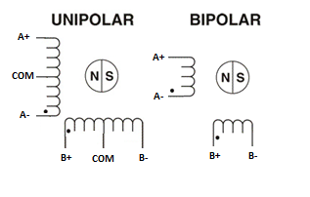

**Working principle:** By energizing one or more of the stator phases, a magnetic field is generated by the current flowing in the coil and the rotor aligns with this field. By supplying different phases in sequence, the rotor can be rotated by a specific amount to reach the desired final position.

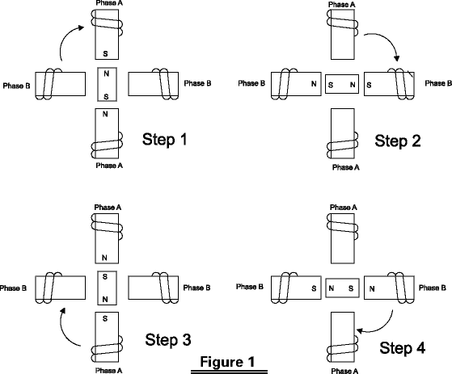

* There are two types of excitation which can be done for 90deg step angle

1. Single phase excitation- Here only one phase is excited at a time. We can achieve step angles like 45deg, 135deg, 225deg,315deg.
2. Two phase excitation- Here only two phases is excited at a time. We can achieve step angles like 90deg,180deg, 270deg,360deg.

**ULN2003A motor driver**: A motor driver is used to run a stepper motor with a micro-controller. The output voltage from micro-controller is +5V, which is not sufficient to drive a stepper motor. So we need to build a higher voltage to drive the motor. The higher voltage can be obtained using a motor driver.

Features:

- Seven Darlington’s pair transistors per package

- Output current 500 mA per driver (600 mA peak)

- Output voltage 50 V

- Outputs can be paralleled for higher current

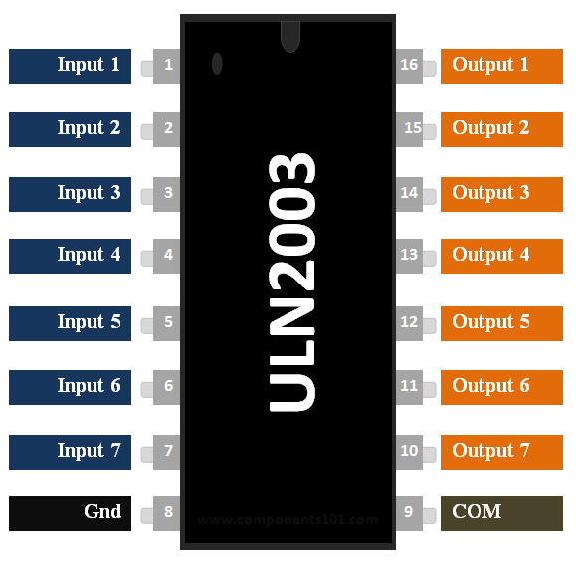

|  |  |  |
| --- | --- | --- |
| **Pin Number** | **Pin Name** | **Description** |
| 1 to 7 | Input 1 to Input 7 | Seven Input pins of Darlington pair transistors, each pin is connected to the base of the transistor and can be triggered by using +5V |
| 8 | Ground | Ground Reference Voltage 0V |
| 9 | COM | Used as test pin or Voltage suppresser pin (optional to use) |
| 10 to 16 | Output 1 to Output 7 | Respective outputs of seven input pins. |

**Example:** In this project, we consider

1. Rotate clockwise- single phase excitation.
2. Rotate Anti-clockwise- single phase excitation.
3. Rotate clockwise- two phase excitation.
4. Rotate Anti-clockwise- two phase excitation

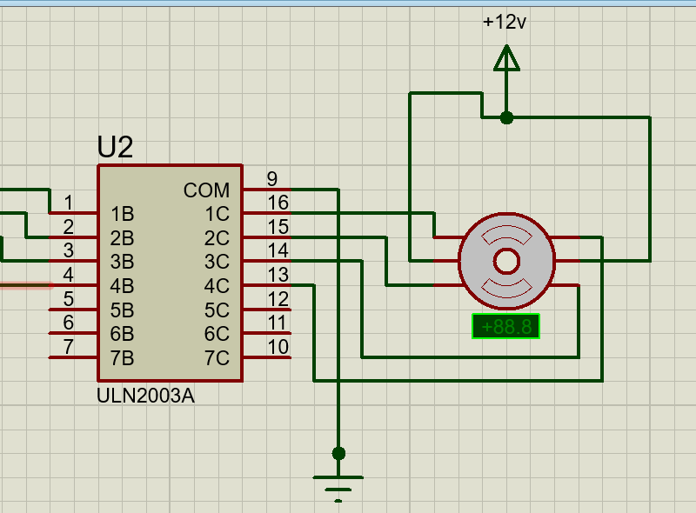

Note: These are the motor-driver connections we have considered. Values to be loaded into ports may differ according to the connections.

* For clockwise- single phase excitation

|  |  |  |
| --- | --- | --- |
| S.NO | Angle required(deg) | Value to be loaded |
| 1. | 45 | 0X08 |
| 2. | 135 | 0X04 |
| 3. | 225 | 0X02 |
| 4. | 315 | 0X01 |

* For Anti-clockwise- single phase excitation

|  |  |  |
| --- | --- | --- |
| S.NO | Angle required(deg) | Value to be loaded |
| 1. | 315 | 0X01 |
| 2. | 225 | 0X02 |
| 3. | 135 | 0X04 |
| 4. | 45 | 0X08 |

* For clockwise- two phase excitation

|  |  |  |
| --- | --- | --- |
| S.NO | Angle required(deg) | Value to be loaded |
| 1. | 0/360 | 0X09 |
| 2. | 90 | 0X0C |
| 3. | 180 | 0X06 |
| 4. | 270 | 0X03 |

* For Anti-clockwise- two phase excitation

|  |  |  |
| --- | --- | --- |
| S.NO | Angle required(deg) | Value to be loaded |
| 1. | 360/0 | 0X09 |
| 2. | 270 | 0X03 |
| 3. | 180 | 0X06 |
| 4. | 90 | 0X0C |

**Algorithm:**

1. Declare port using DDR (data direction register) and declare a while loop for continuous operation.
2. Give the hex value to the port as per the operation required.
3. Provide delay and go to step 2.